

Practices for Secure Software Report

Table of Contents
Document Revision History 3
Client 3
Instructions 3
Developer 4
1. Algorithm Cipher 4
2. Certificate Generation 4
3. Deploy Cipher 4
4. Secure Communications 4
5. Secondary Testing 4
6. Functional Testing 4
7. Summary 4
8. Industry Standard Best Practices 4

Document Revision History

Version | Date | Author | Comments
1.0 | 8/16/2026 | Cyntel Allen

Client



Instructions

Submit this completed practices for secure software report. Replace the bracketed text with the relevant information. You must document your process for writing secure communications and refactoring code that complies with software security testing protocols.

- Respond to the steps outlined below and include your findings.
- Respond using your own words. You may also choose to include images or supporting materials. If you include them, make certain to insert them in all the relevant locations in the document.
- Refer to the Project Two Guidelines and Rubric for more detailed instructions about each section of the template.

Developer
Cyntel Allen

Algorithm Cipher

The Artemis Financial application used the SHA-256 cryptographic hash algorithm to ensure data integrity. SHA-256 is suitable because it generates a 256-bit hash value, and even minor modifications to the original data produce a different checksum. This enables the application to detect any alterations or corruption of data. Employing a secure hashing algorithm, such as SHA-256, is essential for maintaining data integrity and is a key aspect of secure software development.

Certificate Generation
Insert a screenshot below of the CER file.

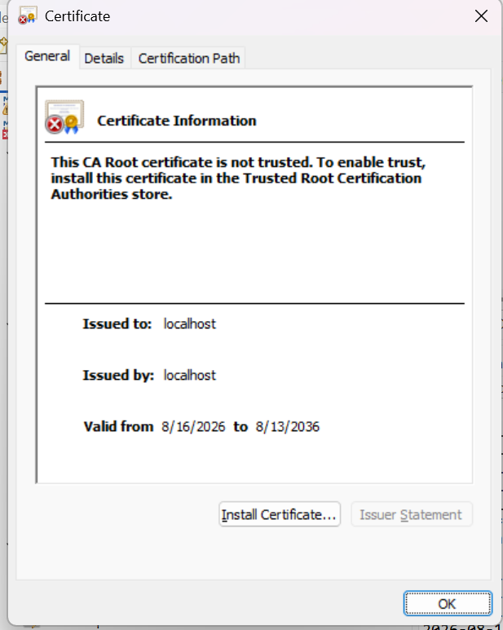

Deploy Cipher
Insert a screenshot below of the checksum verification.

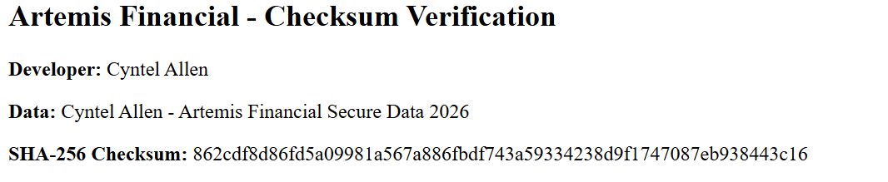

Secure Communications
Insert a screenshot below of the web browser that shows a secure webpage.

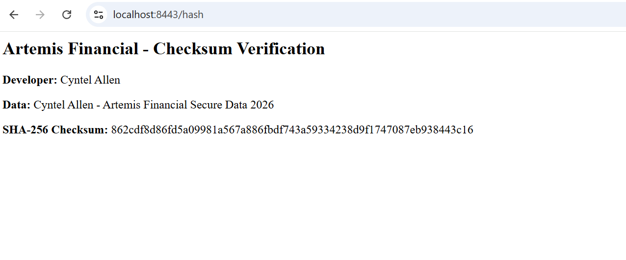

The Artemis Financial app was set up to use HTTPS on port 8443 to ensure secure communication between the client and server. It includes a PKCS12 keystore and SSL certificate, with the certificate’s SAN set to localhost. HTTPS employs TLS encryption to safeguard data exchanged between the browser and app from unauthorized access or tampering. A successful browser connection confirms that the application is operating with the intended secure protocol.

Secondary Testing
Insert screenshots below of the refactored code executed without errors and the dependency-check report.

Following the refactoring of the Artemis Financial application, I conducted secondary testing to ensure it continued to operate correctly and to identify dependency-related vulnerabilities. The application launched successfully without any runtime errors. Additionally, I used the OWASP Dependency-Check tool, which produced a vulnerability report on project dependencies. I reviewed the results to confirm that the security updates did not disrupt the application's proper functioning.

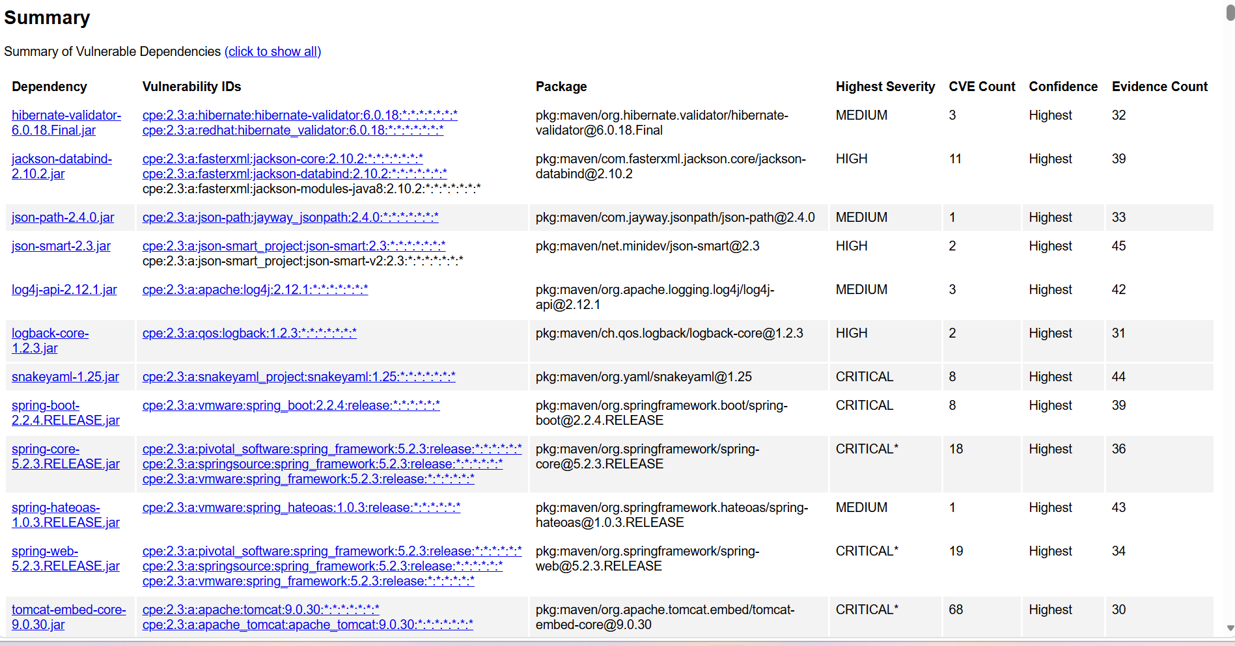
OWASP Dependency-Check report showing the vulnerability analysis of the project dependencies.

Functional Testing
Insert a screenshot below of the refactored code executed without errors.

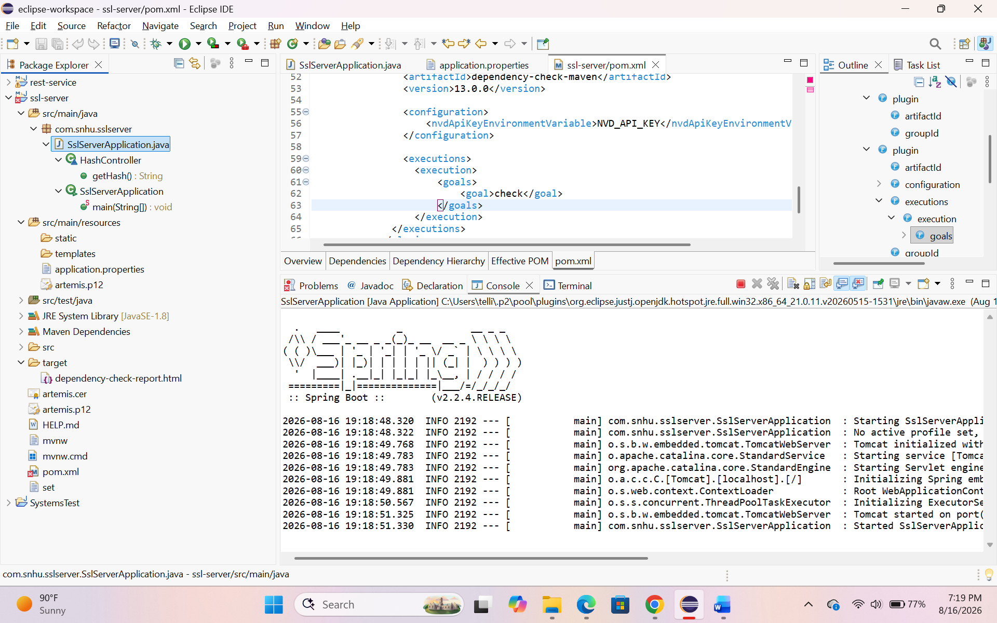

Summary

The Artemis Financial application was effectively refactored to enhance its security. SHA-256 was added to verify data integrity via checksum generation. A PKCS12 keystore with a self-signed certificate was created to enable secure HTTPS communication on port 8443. The certificate was configured with localhost as a Subject Alternative Name to ensure the application could establish a valid secure connection in the browser. Following these security updates, the application was tested to verify proper operation, and OWASP Dependency-Check was used to scan project dependencies for known vulnerabilities. These measures improved the application's confidentiality and integrity while promoting secure development practices.

Industry Standard Best Practices

Throughout the Artemis Financial refactoring process, industry-standard secure software development practices were followed. These included verifying data integrity with SHA-256, protecting data in transit with HTTPS using TLS, employing a PKCS12 keystore and digital certificate, and configuring the certificate with a Subject Alternative Name for localhost. OWASP Dependency-Check was utilized to identify known vulnerabilities in third-party dependencies. Additionally, the application was tested after refactoring to ensure security measures did not interfere with normal operation. Incorporating encryption, secure certificate setup, dependency scanning, and post-refactoring testing helps minimize security risks and fosters the development of more secure and maintainable software.

